**Practical 2: Formatting Output**

Learning objectives:

1. Format column output
2. Create simple reports

Reference: SQL*Plus Command Reference, Chapter 12.

**[You will need to format all the outputs for your assignment. Higher marks will be allocated for a report that is presented in a useful and easy to read manner.]**

The following is a query from the previous lesson:

select order_no, order_date,

food_amount, gst, service_charge,

(food_amount+gst+service_charge) as Total_Bill

from food_order;

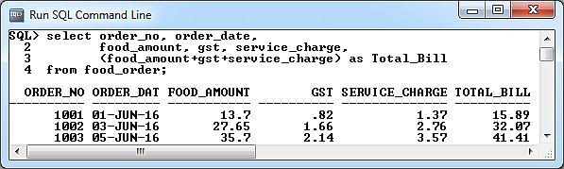

The information is useful but does not seemed “nicely” presented, especially the numbers data.

Formatting numbers:

To present numbers with the proper decimal points, execute the following SQL*Plus commands:

column food_amount format $999.99

column gst format $990.99

column service_charge format $999.99

column Total_Bill format $9,999.99

Execute the previous SQL statement and your result should look like this:

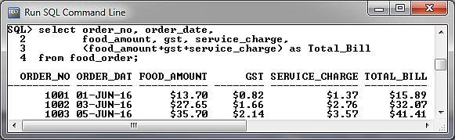

You use the COLUMN command to format the display of column headings and column data.

(Please refer to **SQLPlus User's Guide and Reference** Chapter 12 pg 12-26 for the various options of the COLUMN command)

Changing width of columns:

You can see that the output “ORDER_DAT” is missing the “E”. This is because the size of the data item (dd-Mon-yy) is only 9 characters wide, whereas “ORDER_DATE” is 10 characters wide. To display the column heading in full:

COLUMN order_date FORMAT A10

Now execute:

select order_no, order_date

from food_order;

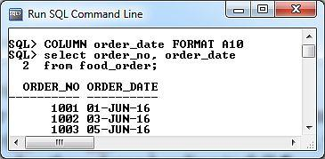

Execute this SQL statement:

select cust_no, phone, gender

from customer;

Now execute:

COLUMN cust_no HEADING "Customer No."

COLUMN phone HEADING "Tel No."

COLUMN gender HEADING "Male/Female"

Run the customer SQL query again.

Explain what happened (and suggest any improvements if any).

**Clearing Column Formatting**

You clear the formatting for a column using the CLEAR option of the COLUMN command.

Setting 1

column food_amount format $999.99

select order_no, food_amount

from food_order;

Setting 2

column food_amount CLEAR

select order_no, food_amount

from food_order;

What the difference between the above two settings?

You can clear the formatting for all columns using CLEAR COLUMNS. For example:

CLEAR COLUMNS

Use formatting commands to improve the following output.

select order_no, menu_id, quantity,price, quantity*price

from order_list;

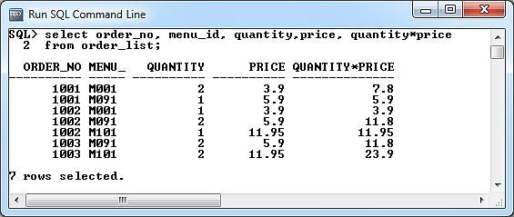

Ans:

[Reference: SQL*Plus Command Reference, Chapter 12.]